Property for economic entities for donation to implement invest project or to create employment, for domestic services, for rent, for ownership at auctions

Building of rural culture club Tulovo, Zelva district  Total area: 235.6 sq.m.  Operative management  Department of ideological work, culture and youth affairs of Zelva district executive committee  (tel. 8 015 (64) 2 55 67) | 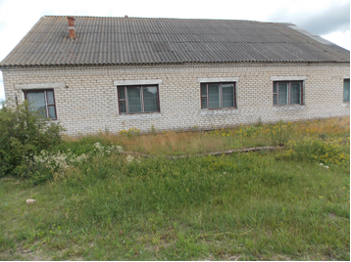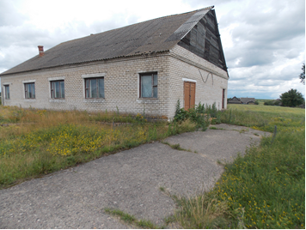
Building of former school  Montyaki, Zelva district  Total area: 851,6 sq.m.  Boiling house of former school  Montyaki, Zelva district  Total area: 63,3 sq.m  Operative management  Department of education of Zelva district executive committee  (tel. 8 015 (64) 2 44 58) | 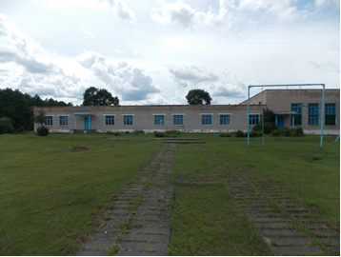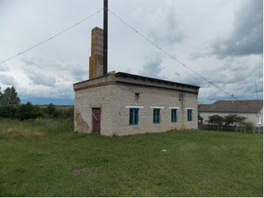
Building of former library-club  Montyaki, Zelva district  Total area: 213,7 sq.m.  Operative management  Department of ideological work, culture and youth affairs of Zelva district executive committee  (tel. 8 015 (64) 2 55 67) | 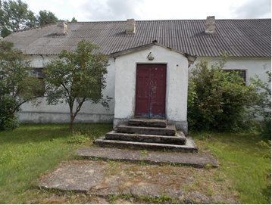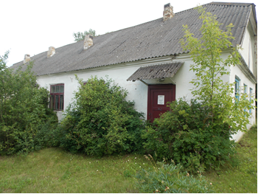
Boiling house, garages of former hospital  Montyaki, Zelva district  Total area: 58,0 sq.m.  Operative management  Health-care institution «Zelva central district hospital»  (tel. 8 015 (64) 2 41 13) | 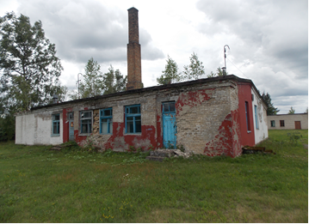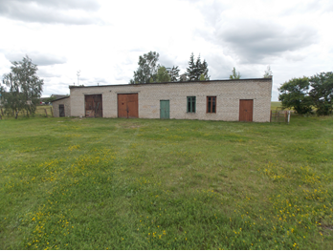
Building of former rural culture club  Yalutsevichi, Zelva district  Total area: 366,7 sq.m.  Operative management  Department of ideological work, culture and youth affairs of Zelva district executive committee  (tel.8 015 (64) 2 55 67) | 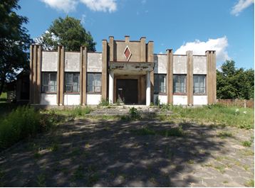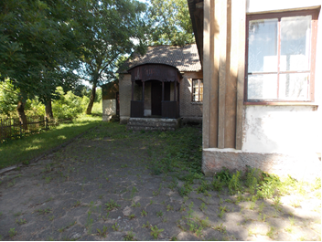
Building of former kindergarten  Kondaki, Zelva district  Total area: 310,3 sq.m.  Operative management  Department of education of Zelva district executive committee  (tel. 8 015 (64) 2 44 58) | 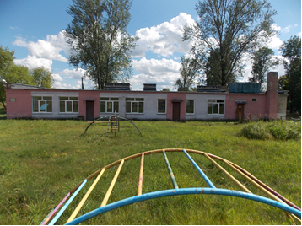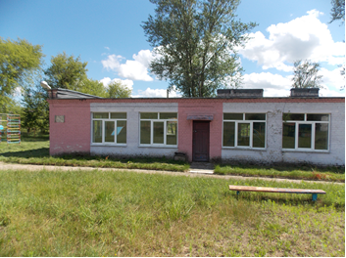
Building of former house of social and cultural services Kondaki, Zelva district  Total area: 233,8 sq.m.  Operative management  Department of ideological work, culture and youth affairs of Zelva district executive committee  (tel. 8 015 (64) 2 55 67) | 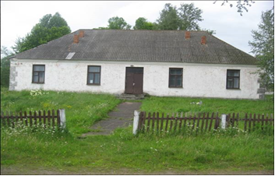
Building of former library-club  Lyahovichi, Zelva district  Total area: 142,2 sq.m.  Operative management  Department of ideological work, culture and youth affairs of Zelva district executive committee  (tel. 8 015 (64) 2 55 67) | 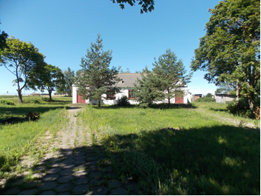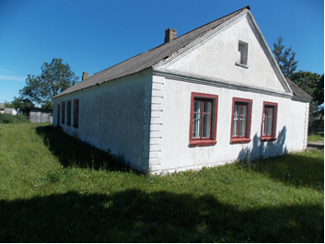
Building of former rural culture club Zoloteyevo, Zelva district  Total area: 262,3 sq.m.  Operative management  Department of ideological work, culture and youth affairs of Zelva district executive committee  (tel. 8 015 (64) 2 55 67) | 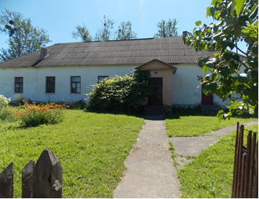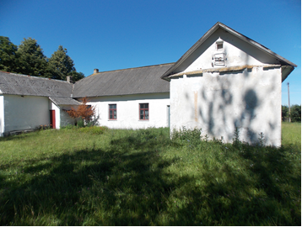
Building of former rural culture club-library  Ostrovo, Zelva district  Total area: 318,7 sq.m.  Operative management  Department of ideological work, culture and youth affairs of Zelva district executive committee  (tel. 8 015 (64) 2 55 67) | 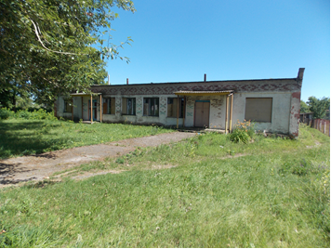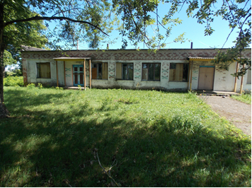
Building of former culture club-library  Staroye Selo, Zelva district  Total area: 235,7 sq.m.  Operative management  Department of ideological work, culture and youth affairs of Zelva district executive committee  (tel. 8 015 (64) 2 55 67) | 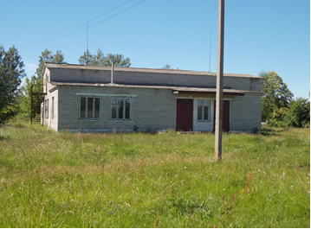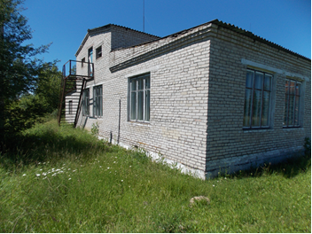
Building of former house of social and cultural services  Gorno, Zelva district  Total area: 203,1 sq.m.  Operative management  Department of ideological work, culture and youth affairs of Zelva district executive committee  (tel. 8 015 (64) 2 55 67) | 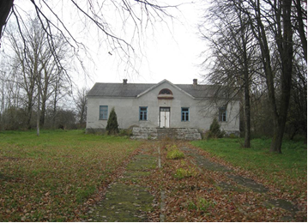
Building of former paramedical and out-patient unit  Krivokonno, Zelva district  Общая площадь: 83 sq.m.  Economic management  State enterprise “Borodichi”  (tel. 8 015 (64) 7 08 67) | 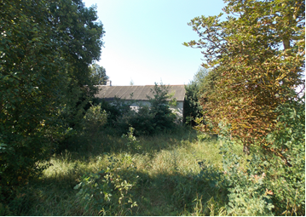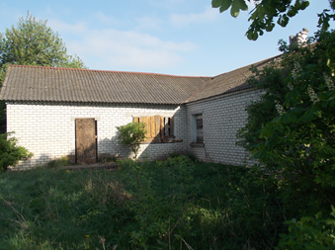
Building of former social services house  Zabagonye, Zelva district  Total area: 50 sq.m.  Economic management  State enterprise “Borodichi”  (tel. 8 015 (64) 7 08 67) | 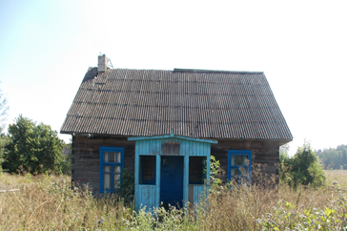
Building of former kindergarten  Madeyki, Zelva district  Total area: 127 sq.m.  Economic management  State enterprise “Borodichi”  (tel.. 8 015 (64) 7 08 67) | 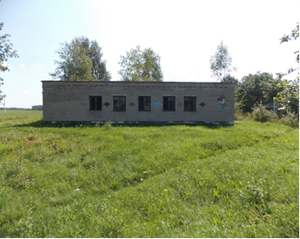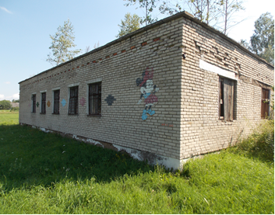
Building of former farm  Lavrinovichi, Zelva district  Total area: 1001 sq.m.  Economic management  State enterprise “Karolino”  (tel.. 8 015 (64) 7 13 68) | 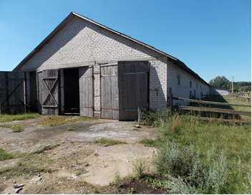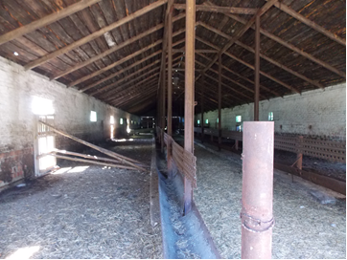
Building of former farm  Ivashkovichi, Zelva district  Economic management  State enterprise “Karolino”  (tel. 8 015 (64) 7 13 68) | 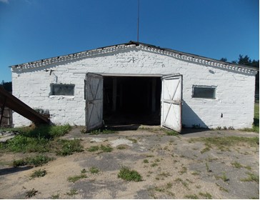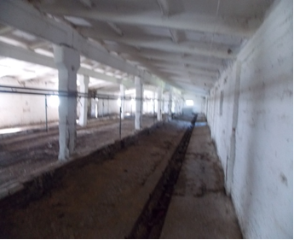
Former administrative building  Kosheli, Zelva district  Total area: 182 sq.m.  Economic management  State enterprise “Karolino” tel. 8 015 (64) 7 13 68) | 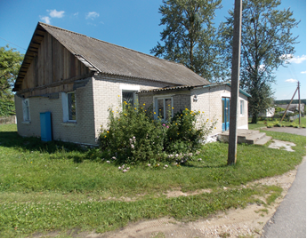
Building of former school  Kosheli, Zelva district  Total area: 91 sq.m.  Economic management  State enterprise “Karolino” tel. 8 015 (64) 7 13 68) | 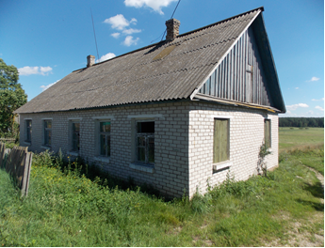
Building of former boiling-house with garages  Kosheli, Zelva district  Economic management  State enterprise “Karolino” tel. 8 015 (64) 7 13 68) | 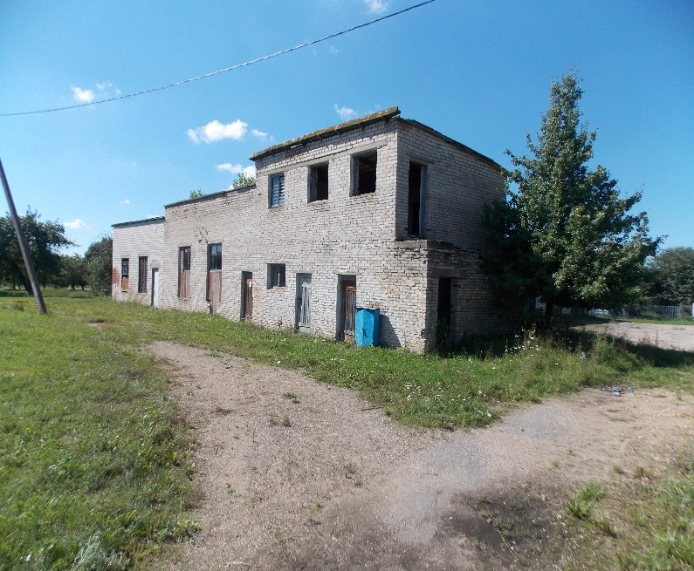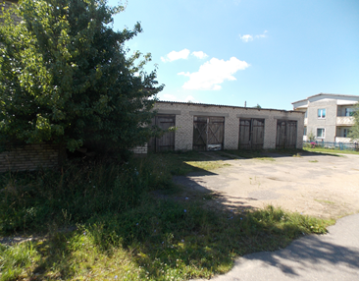
Building of former farm
Kosheli, Zelva district

Economic management
State enterprise “Karolino” tel. 8 015 (64) 7 13 68)
 | 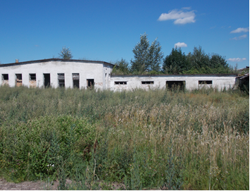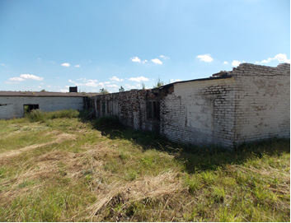
Building of former maintenance workshops  Kosheli, Zelva district  Total area:  Workshops 391 sq.m.;  Service station: 69 sq.m.; | 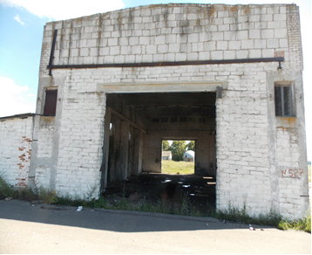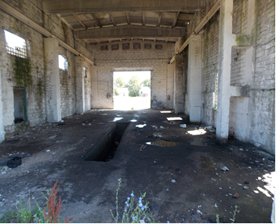
Fuel depot: 42 sq.m;  Sawmill shops: 126 sq.m.  Economic management  State enterprise “Karolino” tel. 8 015 (64) 7 13 68) | 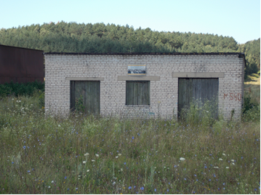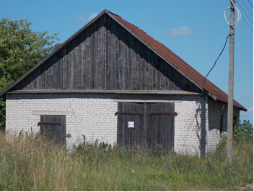
Building of former garages on the territory of workshops  Kosheli, Zelva district  Economic management  State enterprise “Karolino” tel. 8 015 (64) 7 13 68) | 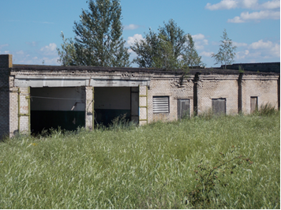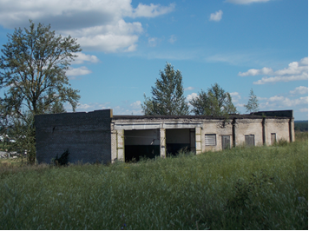
Buildings of former pig farm  Karolin, Zelva district  Economic management  State enterprise “Karolino” tel. 8 015 (64) 7 13 68) | 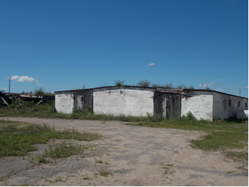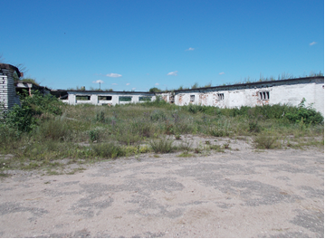
Buildings of former health departments of the district hospital  Zelva, Bolnichnyi,16:  Surgery department  Total area: 445 sq.m.  Therapeutic department  Total area: 417 sq.m.  Operative management  Health-care institution «Zelva central district hospital»  (tel. 8 015 (64) 2 41 13) | 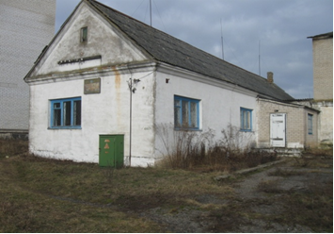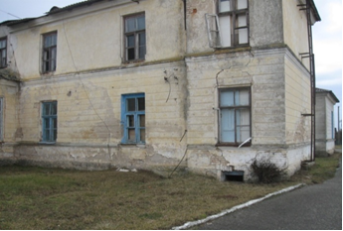
Building of former bookkeeper office  Total area: 136 sq.m.  Building of former laboratory  Total area: 95 sq.m.  Operative management  Health-care institution «Zelva central district hospital»  (tel. 8 015 (64) 2 41 13) | 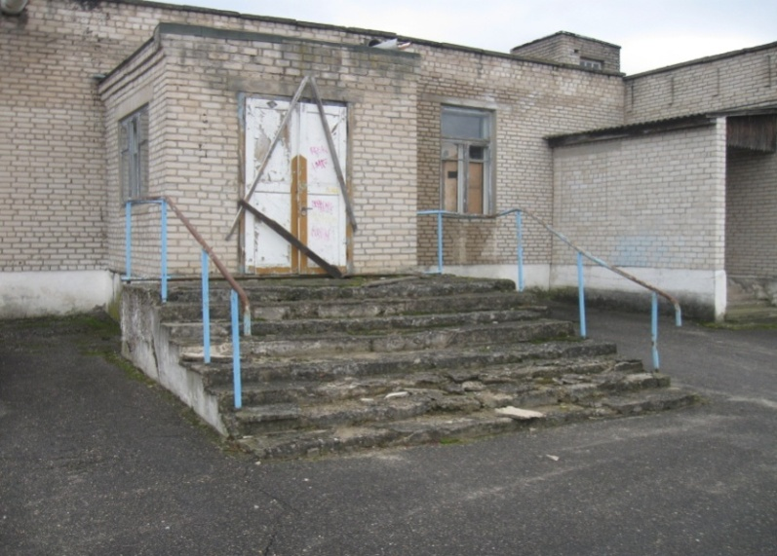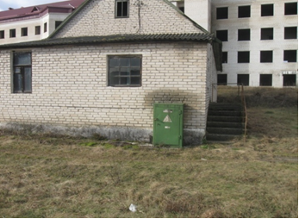
Building of former complex entry point  Slovatichi, Zelva district  Total area: 101,2 sq.m.  Economic management  Zelva district unitary enterprise of domestic services (tel. 8 015 (64) 2 54 14) | 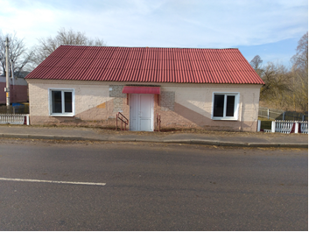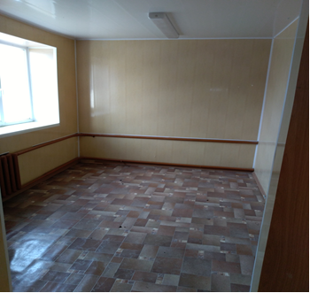
Building of former complex entry point  Krivichi, Zelva district  Total area: 58,0 sq.m.  Economic management  Zelva district unitary enterprise of domestic services (tel. 8 015 (64) 2 54 14) | 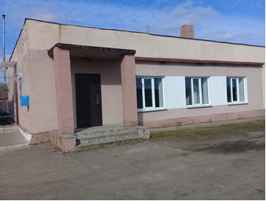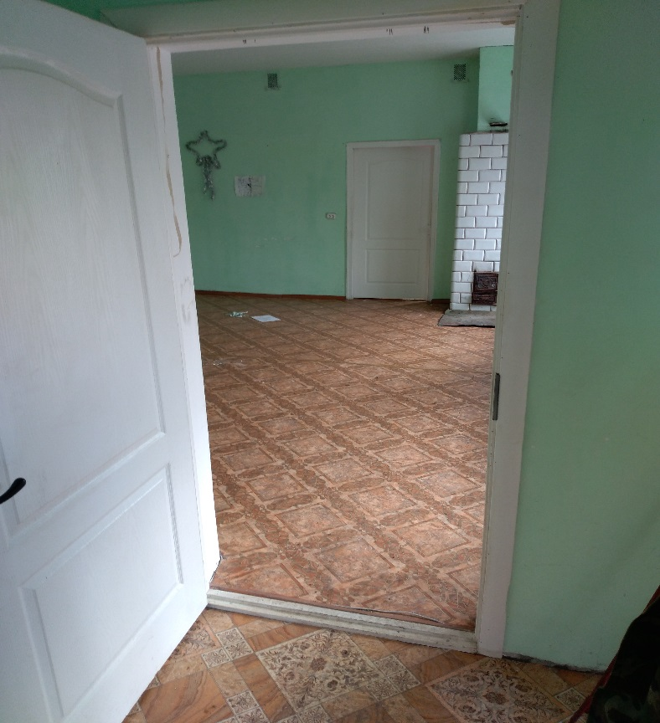
Additional information is available – you can get it from asset holders or in the district executive committee (Tel. 2 45 71, 2 54 18, 2 52 15)

